Teaching and Learning Resources to Prevent Identity-Based Bullying:
Power, Privilege, Oppression, Intersectionality and Identity-Based Bullying Discussion Guide

This document is supplementary material. Each resource contains three components: 1) a recording of a presentation, 2) a PowerPoint slide deck, and 3) a discussion guide. These resources were designed to help you learn more about these topics, before creating a lesson plan for your class. We recommend you watch the recorded presentations to learn more about each topic, and then plan a lesson for your class using active learning based on the provided materials.

We have designed the materials to ensure maximum flexibility, as we know each educator and every classroom is different. Thus, educators can modify the slide decks to fit the needs of their own classrooms. However, the sequence of the materials is important, as the first resource serves as the foundation for the next, and so on.
Every student (and every educator!) will have their own comfort levels for discussing this information, so please plan accordingly. Please ensure you have reviewed the “Intro to Teaching and Learning Resources to Prevent Identity-based Bullying” [available: https://www.prevnet.ca/sites/prevnet.ca/files/intro_to_series_final.docx] before presenting this material.

Regardless of whether you show the recording or tailor the material for your classroom, use this document to help with facilitation. Note that [CLICK] means you should advance the slide during the presentation (animations are used).

Learning Objectives
- Students will be able to explain what identity-based bullying is, and provide examples
- Students will understand what power is, and how it underlies identity-based bullying
- Students will understand privilege and oppression, and how different groups experience privilege and others experience oppression in Canada
- Students will understand what intersectionality is

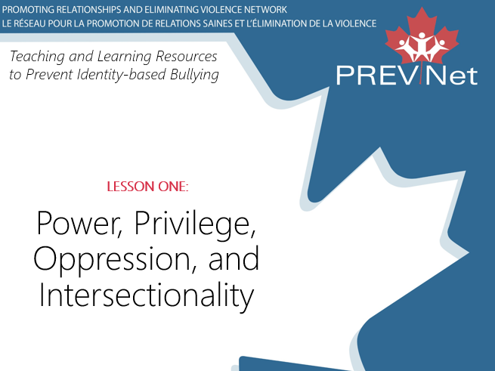
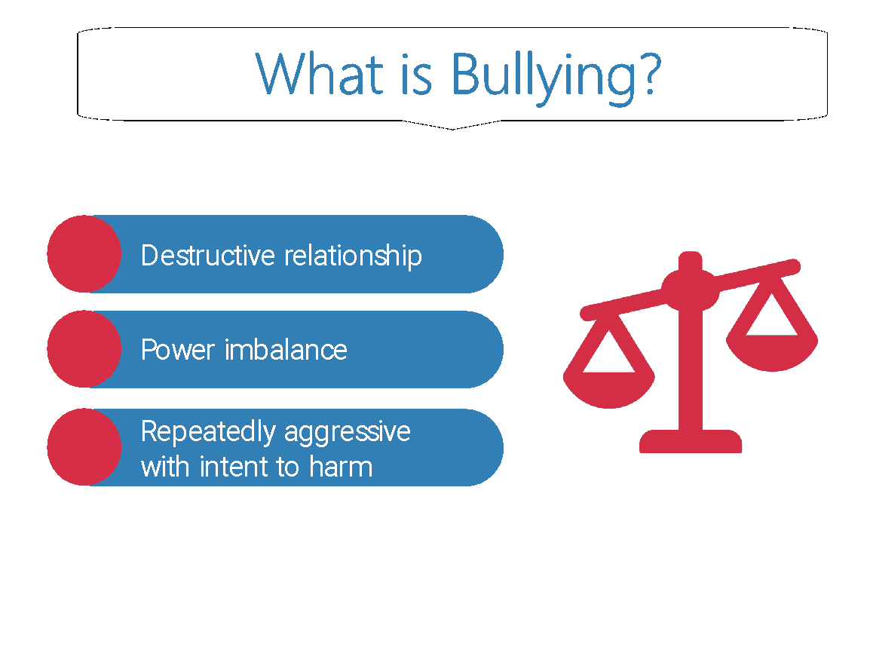 | Say:  - In Canada, at least 1 in 3 teens report being bullied. When we say bullying, we are talking about [CLICK] a destructive relationship [CLICK] where one person or a group of people hold power over another and [CLICK] intentionally acts aggressively to harm them. This is often done repeatedly. Bullying can happen in person or online.  - Someone has power [CLICK] when they have the ability to act in ways that can impact the lives of others, either positively or negatively. Power is related to things like social status and popularity. Youth bully others in order to gain power. Today, we’ll be talking more about the power dynamics that help us understand bullying.
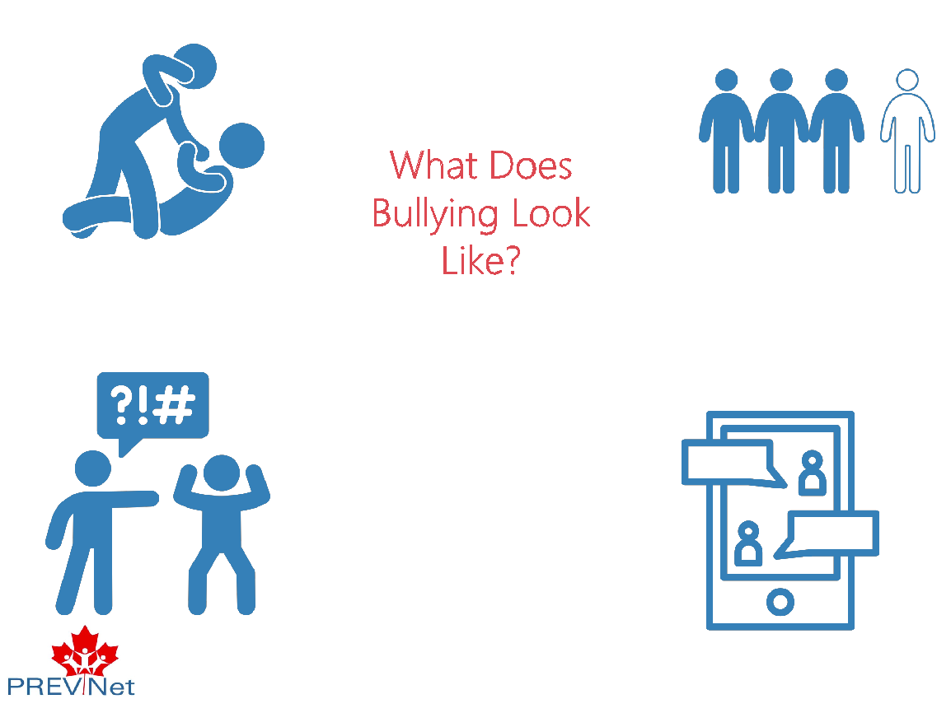 | Say:  - Bullying can take many forms: physical bullying, verbal bullying, social bullying, or cyber bullying.  - [CLICK] Physical bullying could look like hitting someone.  - [CLICK] Verbal bullying could look like calling someone names.  - [CLICK] Social bullying could look like excluding someone from a group.  - [CLICK] Cyber bullying could look like sharing someone else’s private photos on the internet without their permission.
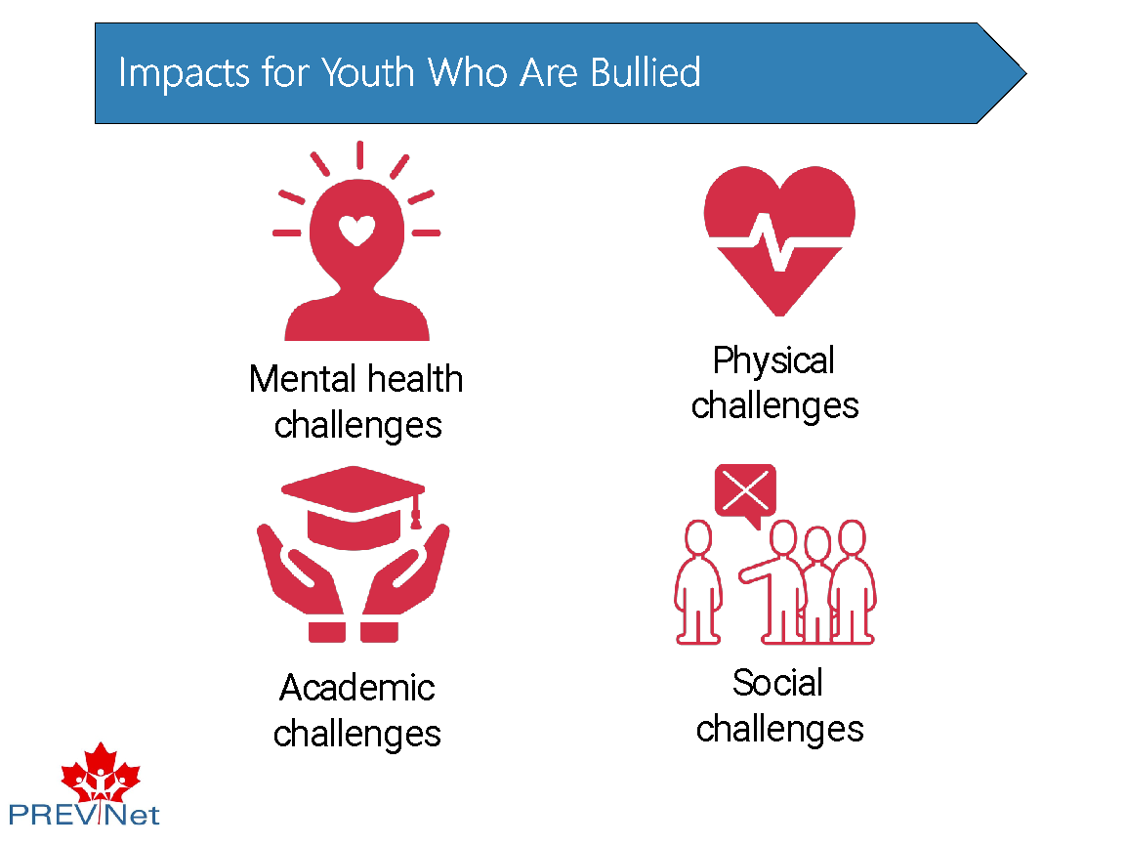 | Say:  - Youth who are bullied are more likely to experience mental, physical, academic, and social challenges.
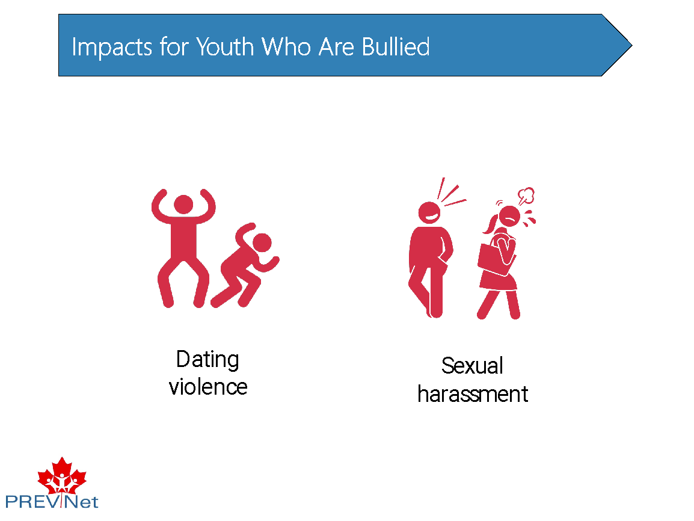 | Say:  - They are also more likely to experience other types of harm later in life, like dating violence or sexual harassment, compared to people who are not bullied.  - [CLICK] Dating violence involves aggressive, threatening, or manipulative behaviour in teen romantic or sexual relationships.  - [CLICK] Sexual harassment includes things like unwelcome comments, touching, or intimidation.
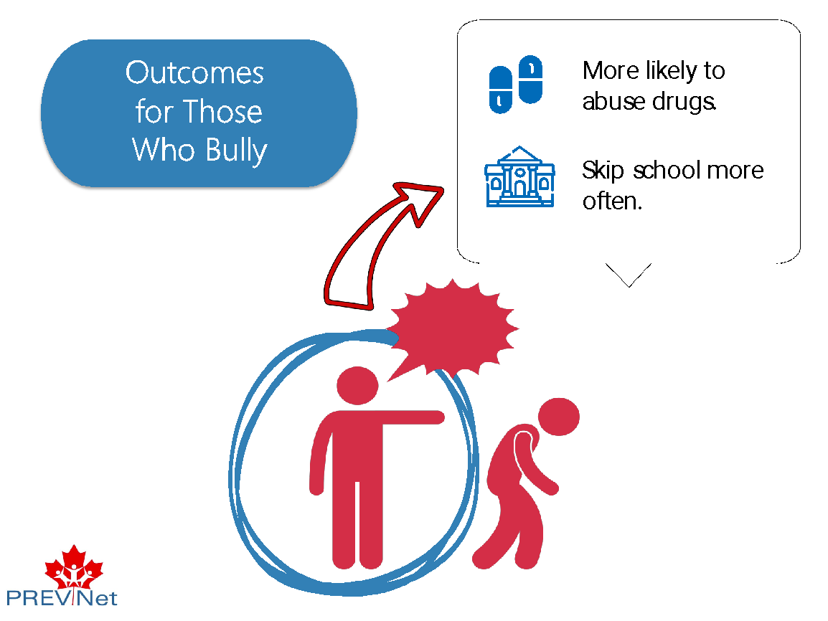 | Say:  - In addition, youth who bully others are [CLICK] more likely to use drugs in an unhealthy way or [CLICK] skip school compared to youth who do not bully others.
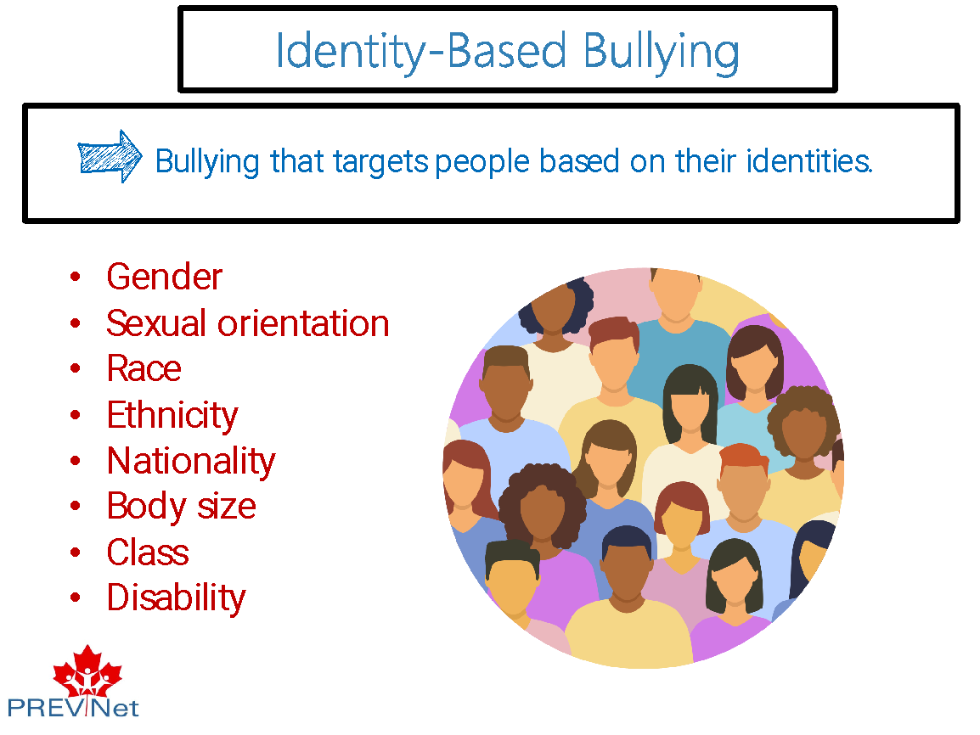 | Say:  - There are many different types of bullying, and bullying is something that anyone can experience. But today we will be talking about one specific type of bullying that only some people experience. It is called identity-based bullying, or [CLICK] bullying that targets people based on their identities.  - Pieces of someone’s identity can include things like [CLICK] their gender, sexual orientation, race, ethnicity, nationality, body size, class, or disability.  - Of course, there are many other pieces of people’s identities, too! These are just a few examples.
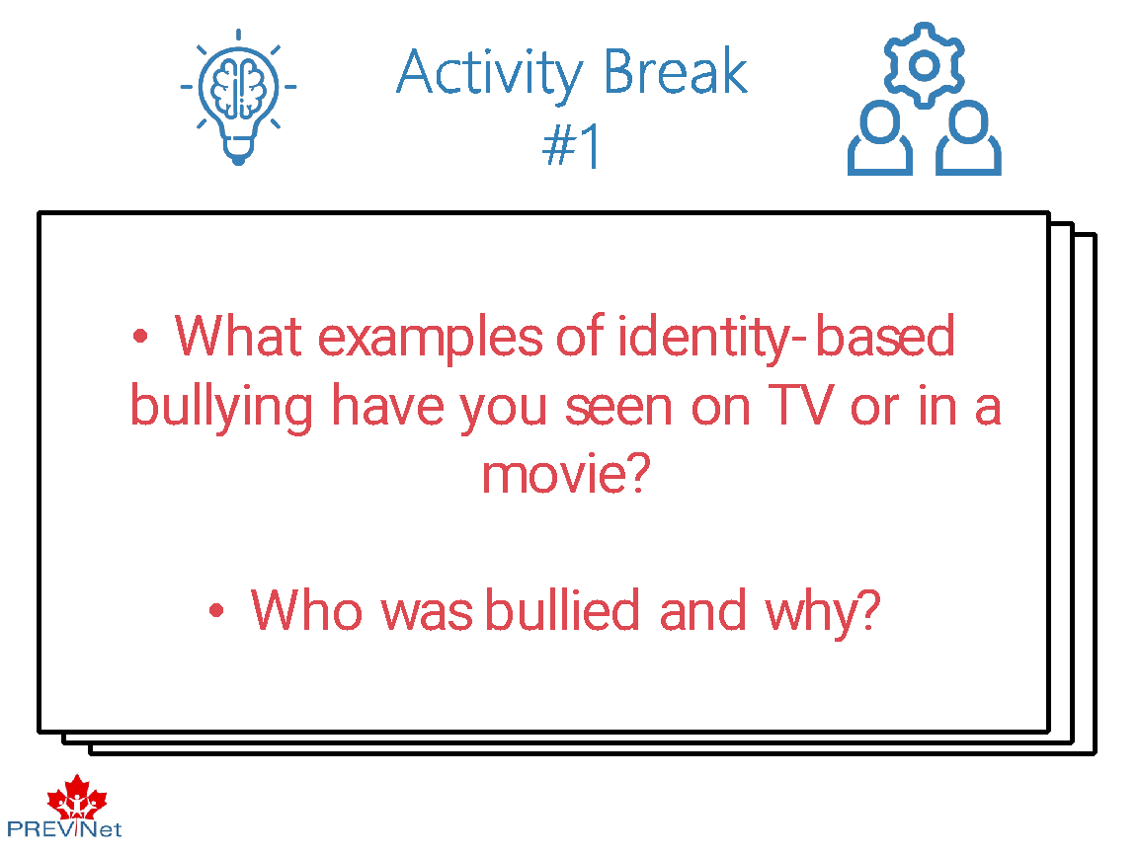 | Ask:  - What ways have you seen people being bullied? Has any of it been identity-based?  - Take a few moments to think about this. Then, in small groups, talk about examples of identity-based bullying you have seen on TV or in a movie. Who was bullied and why?  Facilitation Guidance:  Acknowledge that these conversations are difficult to have because we have all probably participated in identity-based bullying, experienced identity-based bullying, or witnessed it. Be transparent about how talking about this can be hard, and make sure every student decides for themselves how much they want to contribute to the conversation. No one should be pressured to talk. Remember that ‘listening’ counts as participation, too.  Let your students think and discuss amongst themselves. After about 5 minutes, have the students lead the conversation in the classroom. It’s important for students to have the power to lead the conversation. If they are struggling with examples, see below. Focus the conversation on TV shows and movies so that no one is made uncomfortable with real life examples that involve students in the school.  Examples of identity-based bullying (general):  - Calling someone hurtful names because they are gay  - Excluding someone because they are of a different race  - Catcalling someone because they’re a girl  - Making a hurtful social media post about someone based on their physical appearance  - Making fun of someone because they are a wheelchair user  TV shows or movies that may have shown identity-based bullying:  - Mean Girls  - Stranger Things  - Riverdale  - Sex Education  - Heartstopper  Potential answers as to why people were bullied:  - Lower social status  - Less popular
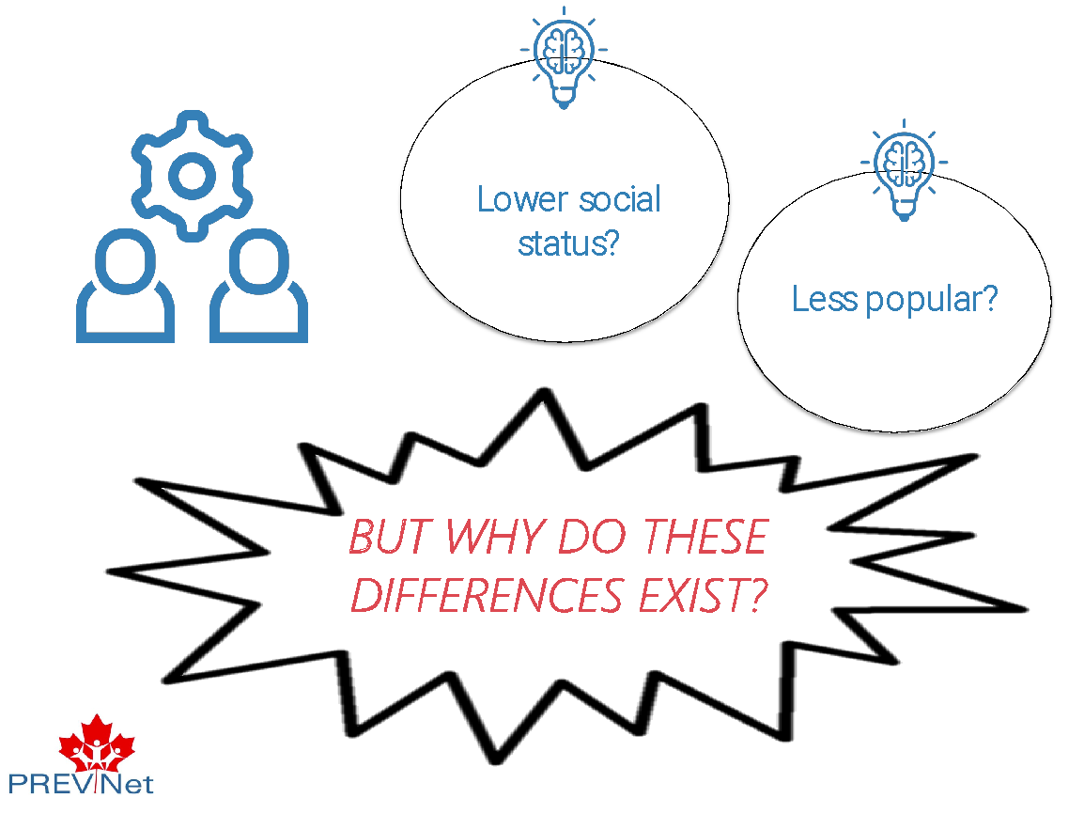 | Say:  - In your conversations, you may have talked about how youth who are bullied because of certain parts of their identity have lower social status or were less popular as compared to the youth who are doing the bullying.  - [CLICK] But why do these differences in power that lead to identity-based bullying exist?
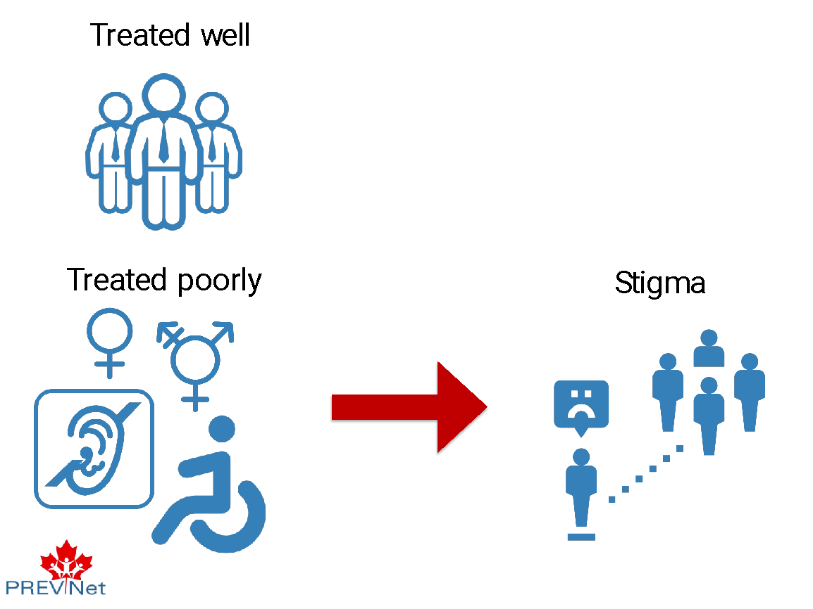 | Say:  - To understand this, we have to zoom out and look at the bigger picture of Canada.  - In the history of Canada [CLICK], White, able-bodied men have been given the most power. Because of this, there are certain groups of people that have been treated well [CLICK] and there are certain groups that have been treated poorly. [CLICK]  - The people who are treated poorly face stigma [CLICK] because society views them as ‘different’. Stigma refers to discrimination against people based on characteristics that make them different from other people who belong to dominant groups in society.
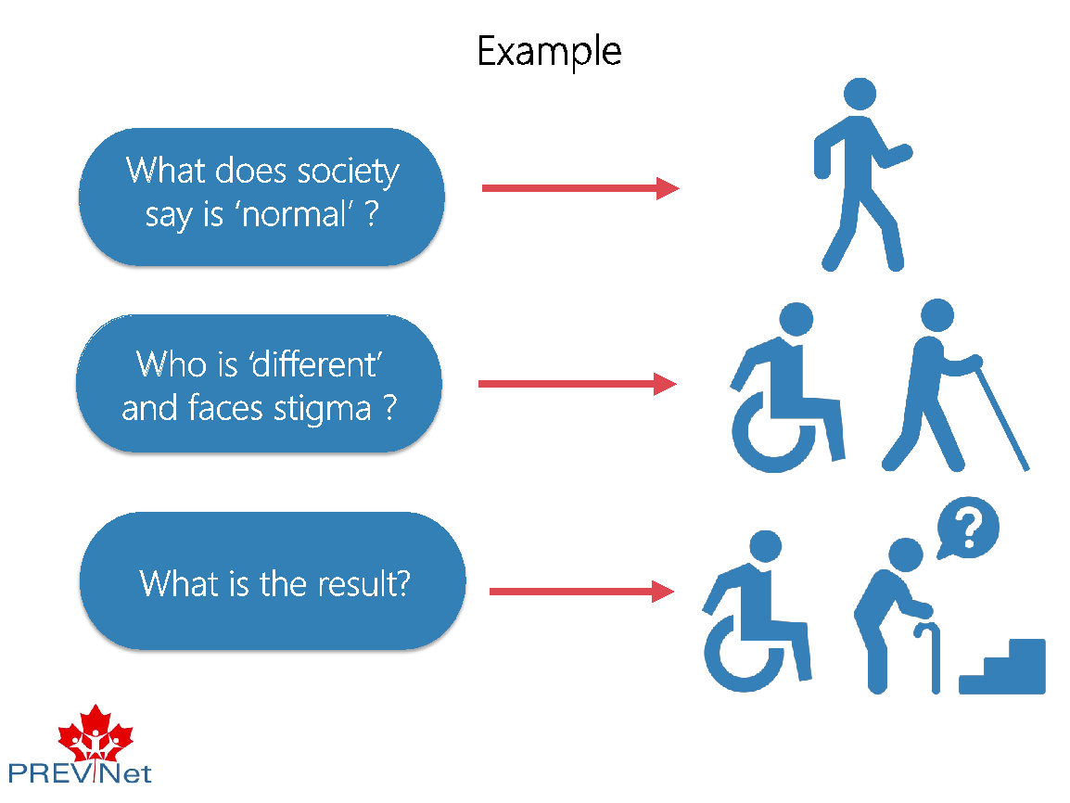 | Say:  - For example, [CLICK] society tells us from birth that it is ‘normal’ to be able to walk in a certain way without any assistance.  - [CLICK] If someone has a disability that affects their ability to move, and uses a device such as a wheelchair or cane to get around, they are therefore seen as ‘different’ and face stigma.  - As a result, [CLICK] people who are disabled have been excluded in many social settings, and their needs have been ignored in many physical spaces, as evident by restaurants and shops that do not have ramps for accessibility or spaces that fit wheelchairs. [CLICK]
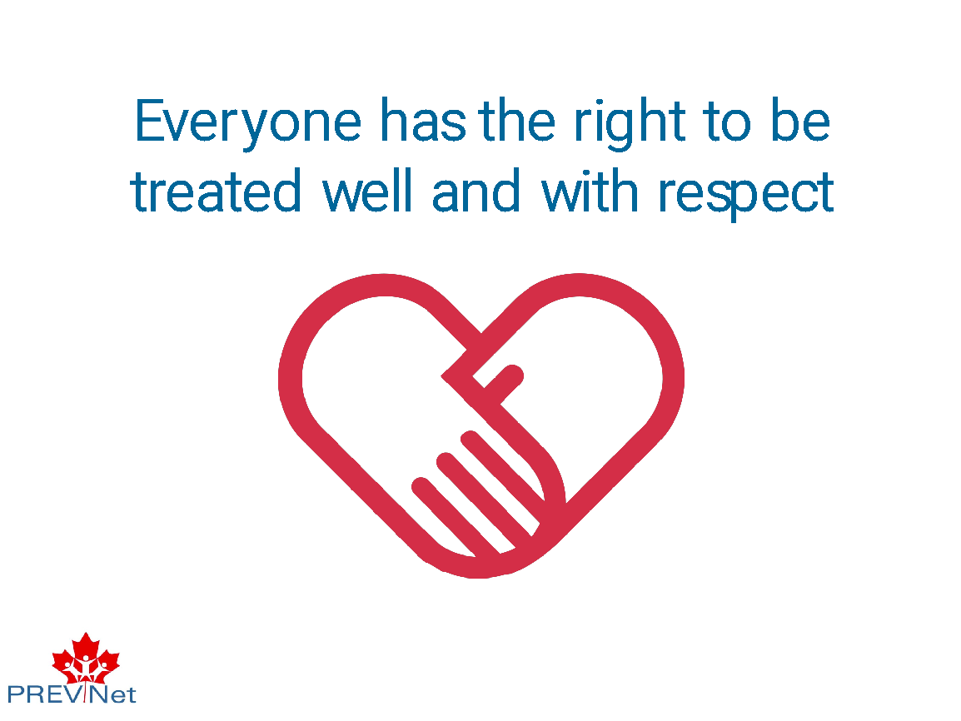 | Say:  - But, everyone has the right to be treated well and with respect. This includes in their relationships, meaning children and youth have the right not to experience bullying. So, how do we use knowledge about stigma and discrimination to prevent identity-based bullying, and make sure everyone is treated well?  - The first step is identifying what society has told us about who should be treated well and who should be treated poorly, and why. This will help us better understand who has continued to be treated unfairly, just because of the group they belong to.
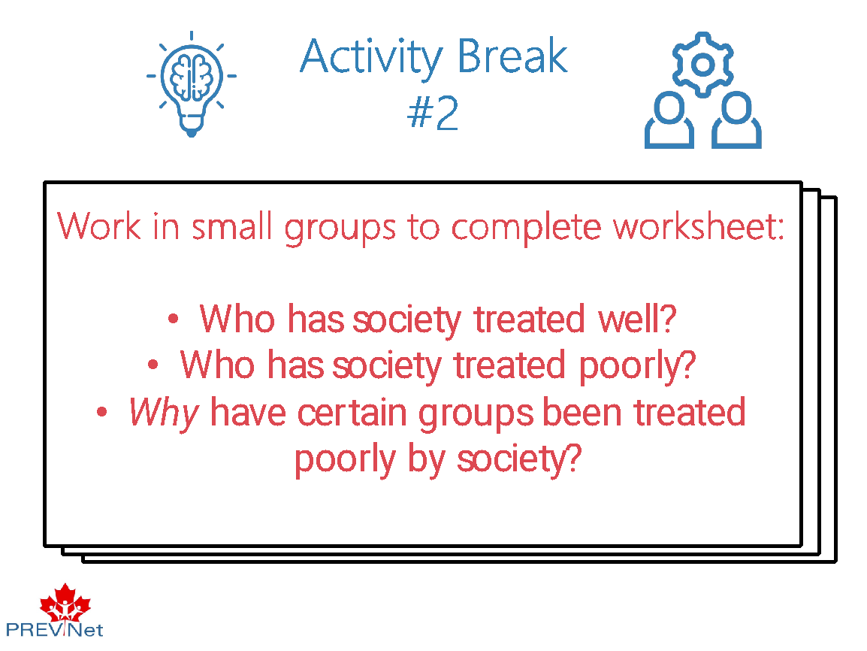 | Ask:  - Working in small groups, complete this worksheet [use handout]. Think about which groups society has treated well, and which groups society has treated poorly.  - Importantly, also think about WHY certain groups have been treated poorly by society.  Facilitation Guidance:  We want to be able to understand what identity-based bullying is, but we do NOT want to give students ideas of ‘how to bully’. In other words, we want students to think about how society in general has reinforced stereotypes or stigmas. We also want to be mindful of how we talk about these examples. They are not just hypothetical scenarios, they are often real-life experiences that students in your classroom have lived through. Be mindful of this, and how you navigate discussions accordingly.  Also make sure you are not looking to students who come from marginalized groups to answer all the questions of majority group students about their identity/ies – tell majority group students that if they want to know more, it is important they do this learning on their own, and that you can help them find good resources for this learning.  - When discussing the ‘why’ behind differences, direct the conversation to reflect larger systemic issues (i.e., racism, sexism, ableism) so students understand the groups who have been oppressed are not at fault in any way, and that this oppression is about who has power and how it is maintained, not individual problems or deficits. You will need to consider where your students are at developmentally, and scaffold this activity accordingly (see “Intro to Teaching and Learning Resources to Prevent Identity-Based Bullying” for more detailed information).  - In the activity, students will work through various examples that are included in the worksheet. Make it clear to students that the worksheet includes some examples, but there are many others that aren’t included in the worksheet (e.g., sanism). Based on the worksheet, here is a list of groups that students could have identified as being treated poorly: disabled, neurodiverse, lesbian, gay, queer, pan, bi, asexual, women and gender diverse, older people, children (under 18), ethnocultural (e.g., Black, Asian, Latinx) people, Indigenous peoples, poor, larger bodies, newcomer, or immigrant. Make it clear that not everyone who identifies as a group who has experienced oppression will experience identity-based bullying, but that everyone who has experienced identity-based bullying is part of a group that has experienced oppression. Thus, society plays a role in who is more likely to be bullied, and who is more likely to be shielded from bullying. The conversation should tie back to larger structural issues (e.g., racism) that lead to the differences in power we see in society, to ensure that students understand the unfair treatment of oppressed groups is in no way their fault.  If you want to dive deeper into these conversations, consider these activities:  - https://ccrweb.ca/en/anti-oppression  - http://lgbtq2stoolkit.learningcommunity.ca/training/power-flower/
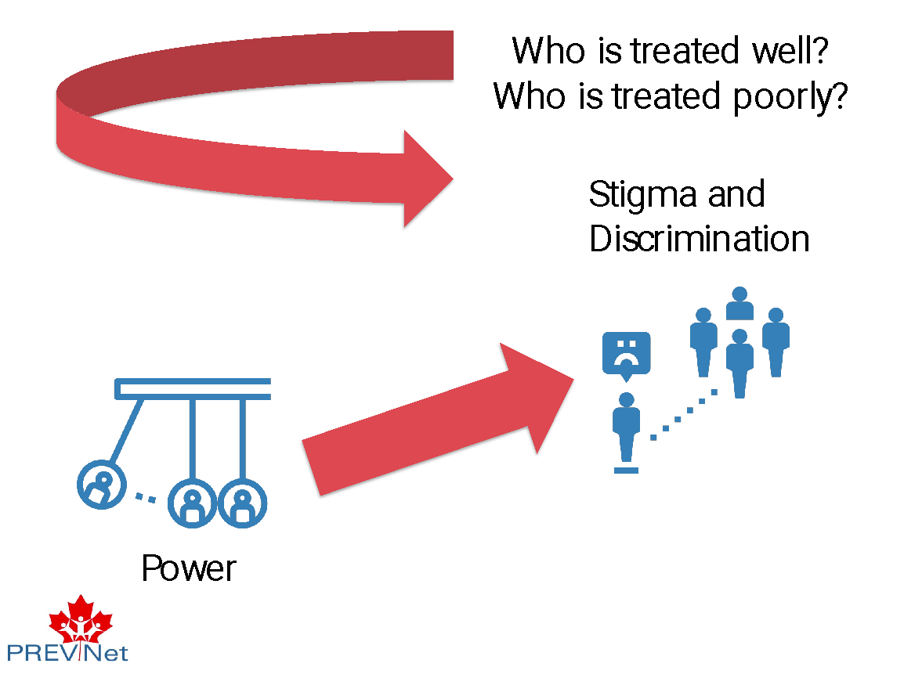 | Say:  - Understanding [CLICK] who gets treated well and who gets treated poorly is important because [CLICK] it helps us see where discrimination and stigma come from, which is important for recognizing the roots of identity-based bullying.  - Stigma and discrimination arise because of [CLICK] differences in power between different groups in society.  - These differences in power are based on harmful social beliefs and systems, and not individual-level abilities.
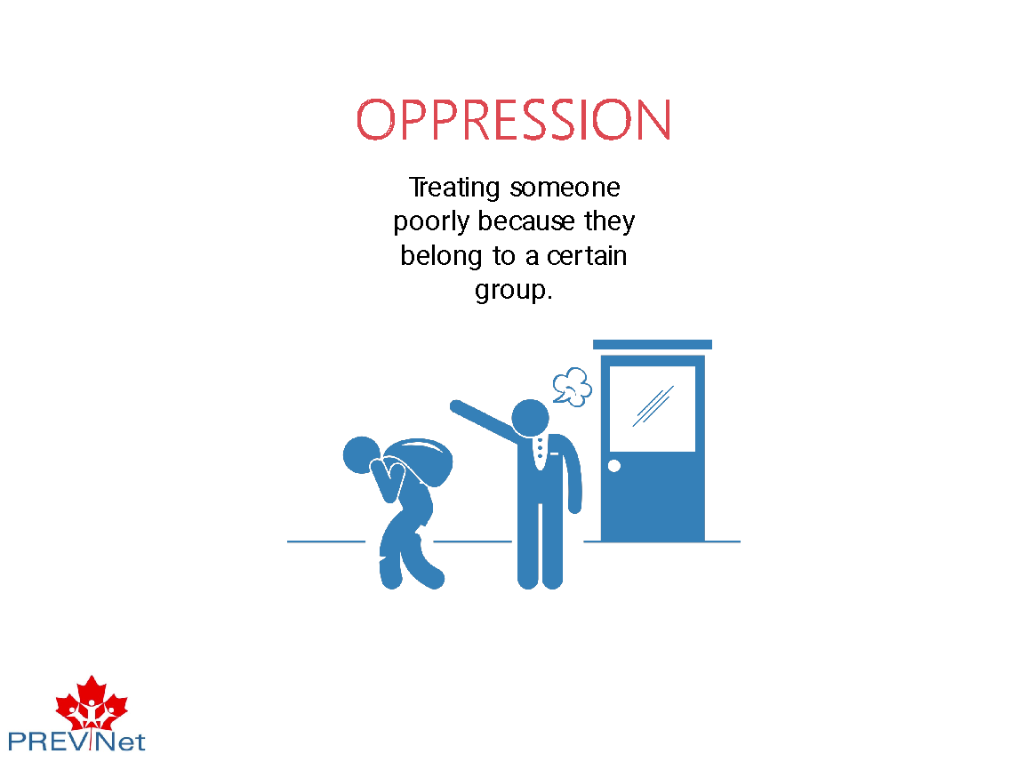 | Say:  - Thinking about power more, [CLICK] when someone is treated poorly just because they belong to a certain group, we’re actually talking about something called oppression. People who are oppressed are denied the right to be fully themselves and are not always accepted by society.
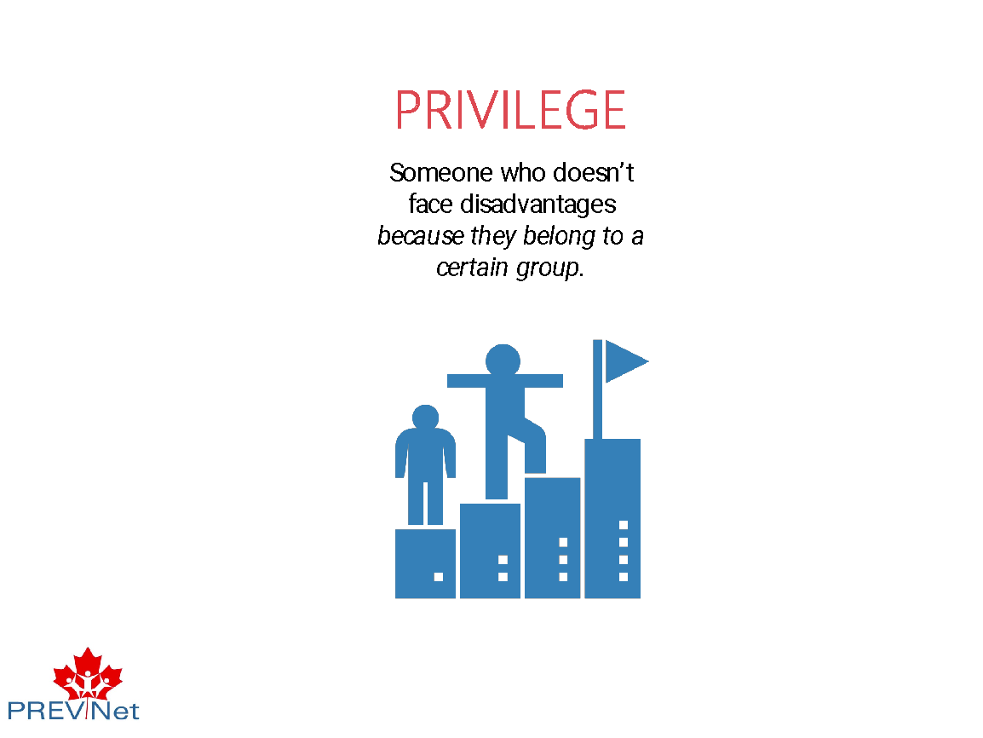 | Say:  - When we think about who hasn’t been treated poorly because of their identity, [CLICK] we’re actually thinking about something called privilege. Someone has privilege when [CLICK] they don’t face disadvantages just because they belong to a certain group. People in privileged groups are usually treated better than others, and are typically more accepted by society.  - For example, White people can usually drive through a wealthy neighbourhood without being pulled over by police because they don’t seem ‘out of place’ in that context, and they can walk through a store without being followed by a store clerk because the clerk doesn’t assume they will steal something. Never having to experience that (something known as ‘racial profiling’) is a privilege.
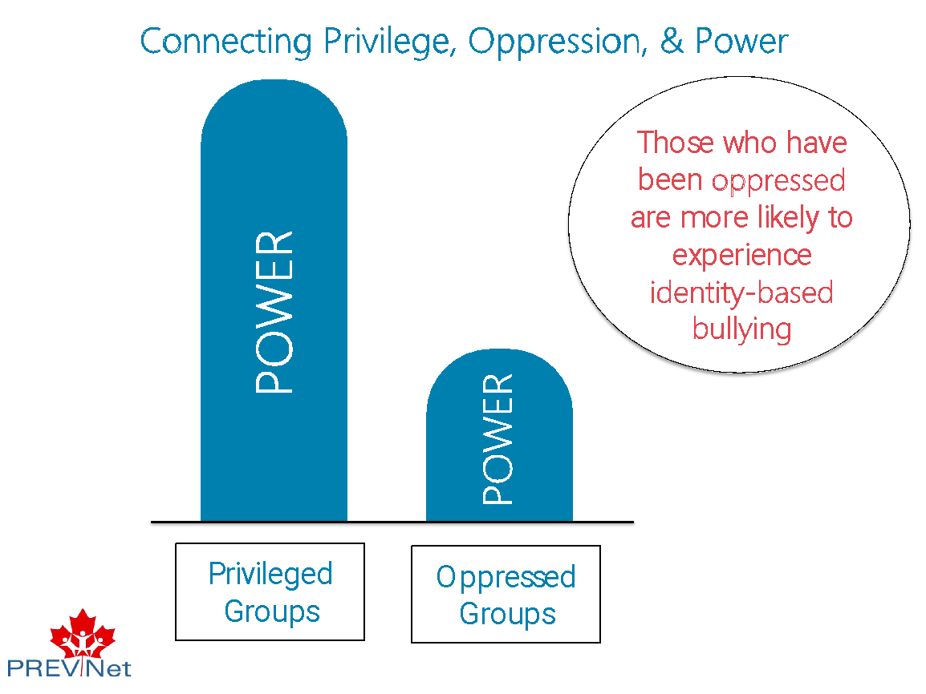 | Say:  - As we’ve just identified in the activity, there are certain groups that have been given privileges and other groups that have been oppressed over time.  - When this happens, this continues to build differences in power between groups of people. Those with more privilege continue to gain more power, and those who are oppressed continue to have less power.  - [CLICK] Understanding differences in power can help us understand identity-based bullying, because identity-based bullying is rooted in power. Differences in power based on gender, race, ethnicity, sexual orientation, and disability, among other things, have been created by those with power in society, by oppressing some groups and privileging others over time. Power imbalances in the larger society are then a root cause (meaning, they serve as part of the foundation of behavior) of who gets bullied and who does the bullying.  - Not all people who have privilege will engage in identity-based bullying. And not everyone who identifies as a group who has experienced oppression will experience identity-based bullying, but that everyone who has experienced identity-based bullying is part of a group that has experienced oppression. Thus, society plays a role in who is more likely to be bullied, and who is more likely to be shielded from bullying. However, the differences in power do make it more likely for those who have been oppressed to experience identity-based bullying.  - Thus, identity-based bullying isn’t just about targeting an individual. It’s also about the negative attitudes people may have about a group that people identify with. These attitudes are learned over time by living in a society where power is used to privilege some and oppress many others.
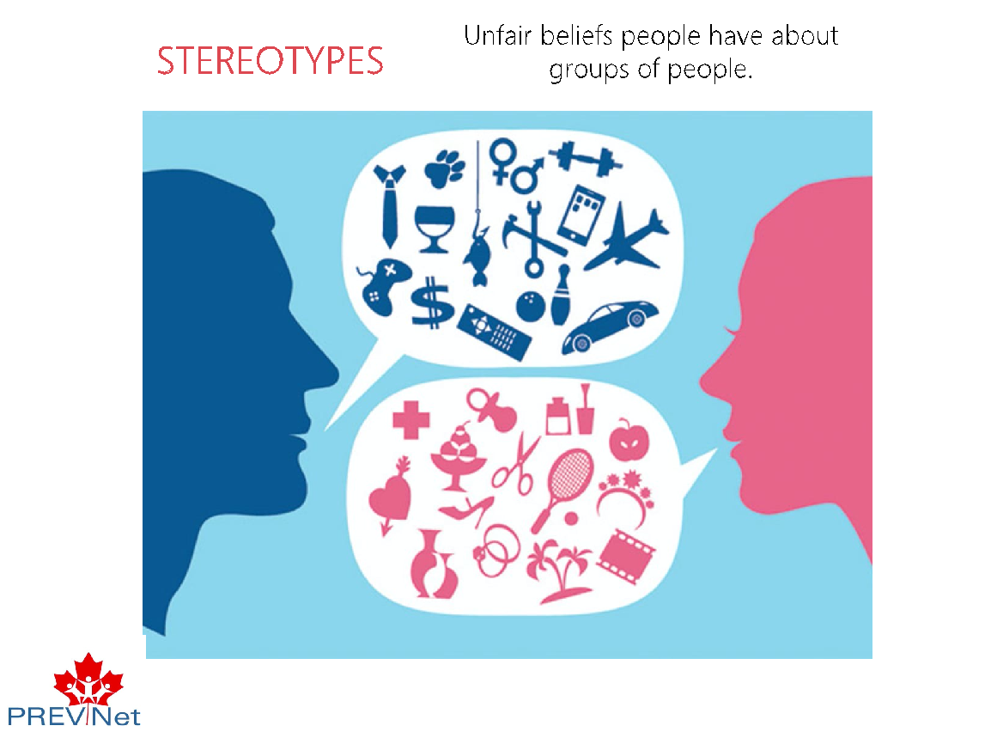 | Say:  - Ultimately, these attitudes can show up as something called stereotypes.  - Stereotypes are [CLICK] the unfair beliefs people have about other groups of people.  - Stereotypes develop over our lifetimes through interacting with family, friends, and our communities. Sometimes we learn to simply accept the beliefs we’ve heard about other groups of people. Many times, we may not even be aware of our assumptions and biases, and how they can be harmful.  - People who belong to groups who are oppressed, and thus have less power, are subjected to stereotypes. The unfair beliefs that persist about these groups continue to maintain the power imbalances we see at the societal level.
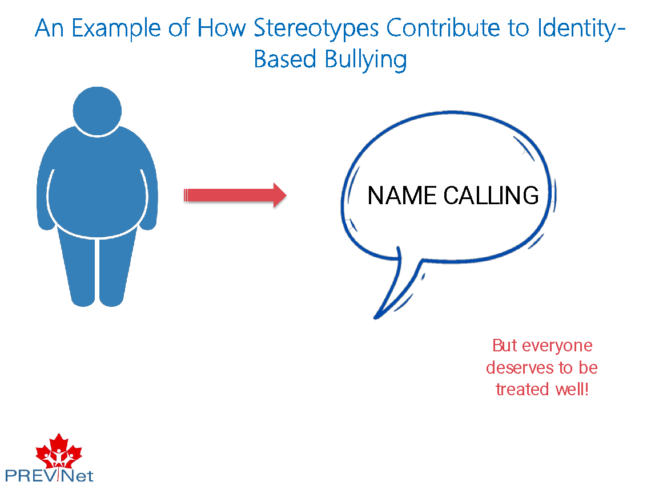 | Say:  - For example: A stereotype people have about [CLICK] people with larger bodies is that they are lazy. Because of this, youth may bully people with larger bodies by [CLICK] calling them names or deciding to not pick them as a sports teammate in gym class.  - Using stereotypes to fuel identity-based bullying reflects the harmful beliefs that children and youth may have about an entire group of people (in this case, people with larger bodies).  - These acts of identity-based bullying continue to oppress people based on their identity, further contributing to power imbalances. [CLICK]  - But, as we talked about before, everyone deserves to be treated well, and has the right not to experience bullying based on pieces of their identity like body size, race, ethnicity, nationality/newcomer status, gender, sexual orientation, class, or disability.
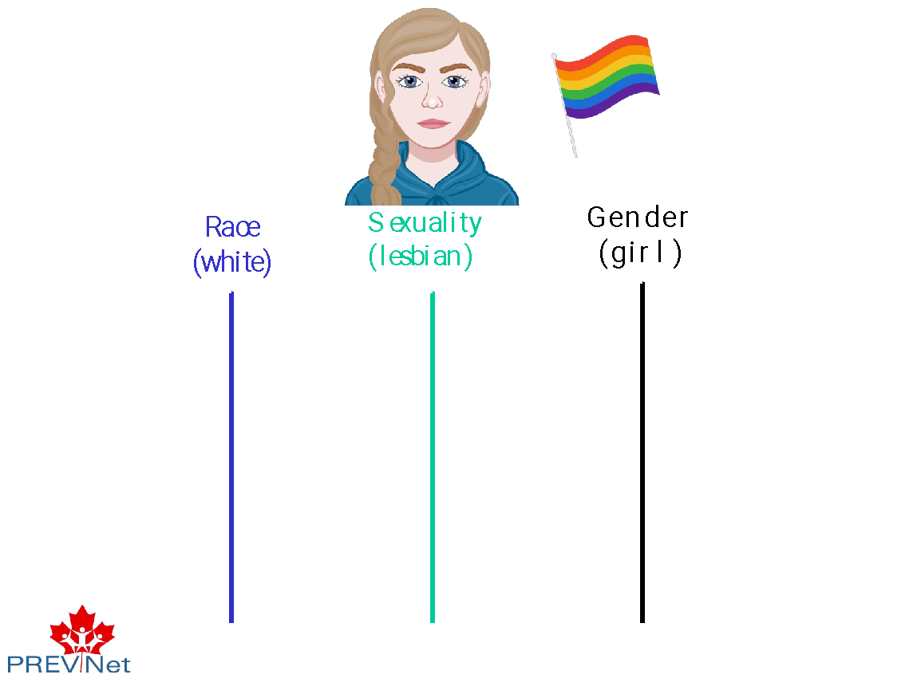 | Say:  - So far, we have been talking about each of these groups separately. But, we are all part of many different groups. Each of these group identities influence the way people move through the world. That means it impacts how others perceive you, what supports are available to you, what opportunities are accessible to you, etc.  - Because of this, when we think about identity-based bullying and how to prevent it, we also need to think about how identifying as part of multiple different groups can shape bullying experiences and behaviour.  - For example, [CLICK] let’s think about someone who identifies as a White [DOUBLE CLICK], lesbian [DOUBLE CLICK] girl [DOUBLE CLICK]. That means that to understand her experience of being treated well or poorly, we need to think of how all the different pieces of her identity fit together.
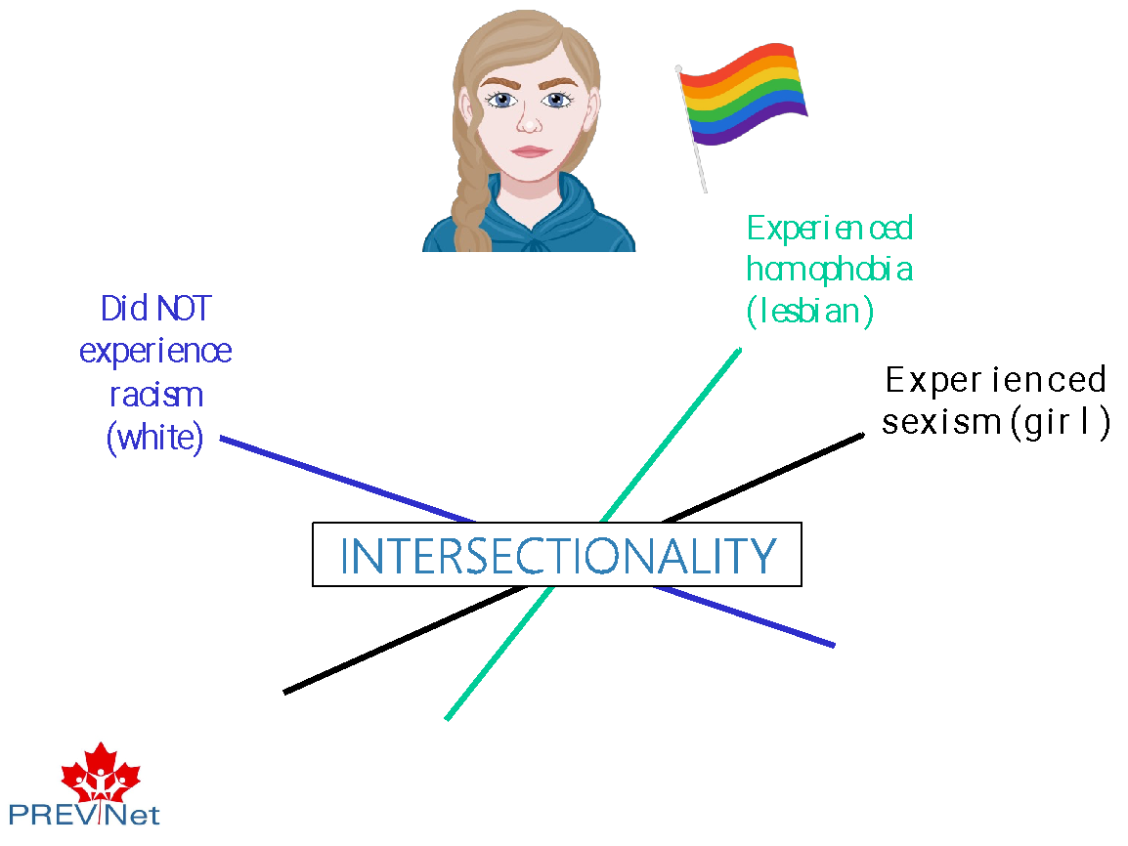 | Say:  - She may have experienced oppression because she’s a girl [CLICK] and because she’s lesbian [CLICK]. However, she did not face oppression based on her race because she’s White [CLICK] and living in Canada.  - So it’s usually not as simple as just “this person experiences privilege” or “that person experiences oppression”.  - Instead, we have to think about how someone’s different identities impact their experiences. This concept [CLICK] draws on a larger theory called intersectionality, developed by Black and Latina women scholars.
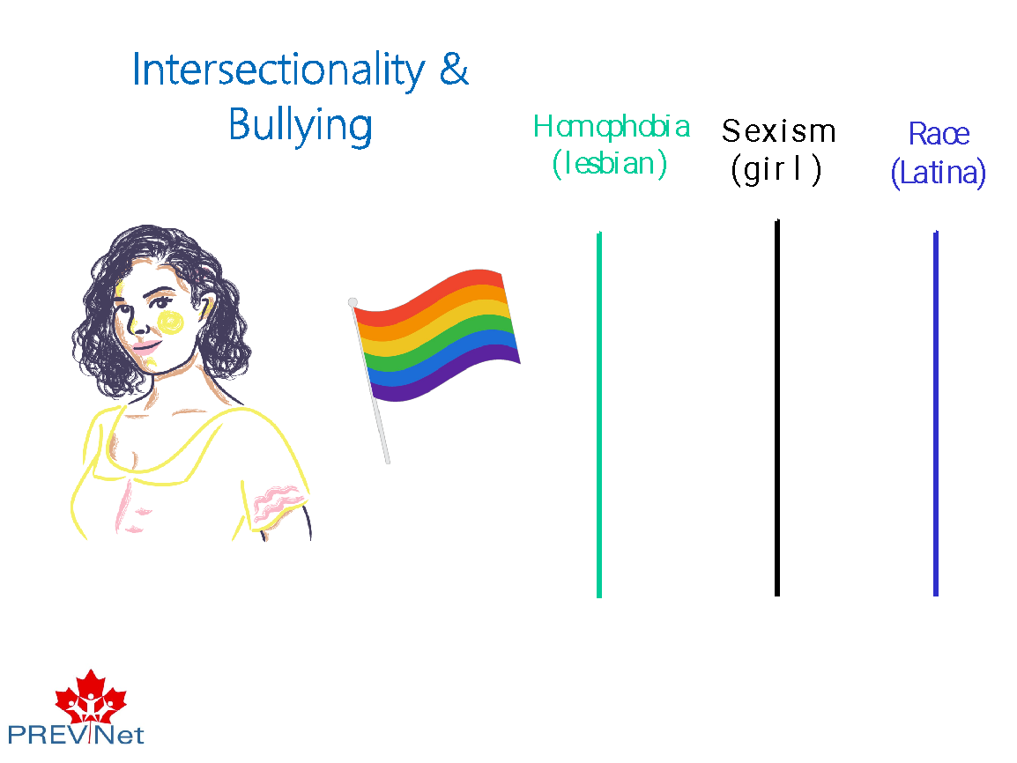 | Say:  - One important thing to understand is that people who experience oppression due to multiple pieces of their identity are at higher risk for bullying.  - For example, think about Ryan [CLICK], a lesbian girl who isn’t White like the last example, but instead is Latina. She experiences homophobia [CLICK] because of her identity as a lesbian, sexism [CLICK] because she is a girl, and racism [CLICK] because she is Latina and living in Canada.  - What might the experience of homophobia, sexism, and racism look like for Ryan? Said another way, what stereotypes or stigma might Ryan face?
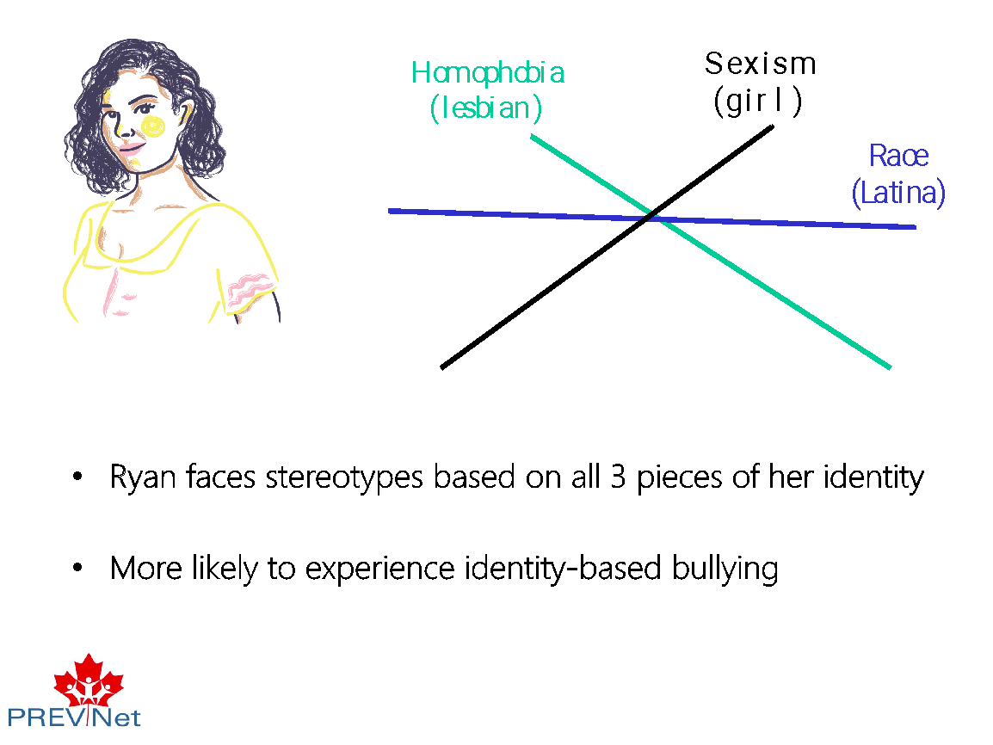 | Say:  - To fully understand Ryan’s experience, we can’t think about homophobia, sexism, and racism as separate pieces. Instead, we need to think about how they fit together [CLICK]. Said another way, we can’t just think about her experience as a lesbian, a Latina, and a girl…instead, we need to think about what her experience is as a lesbian Latina girl.  - Let’s think about that a bit more. We have discussed three forms of oppression that Ryan experiences because there are three pieces of her identity that make her different from majority groups. But, these identities also interact to mean her experiences as a lesbian Latina girl are unique, and that she would hold even less power as compared to a White lesbian or a Latino boy.  - For example, TV shows, movies, and songs have repeatedly stereotyped Latinas [CLICK] as women who wear tight clothing, have a short temper, and often work as maids. Because of this, [CLICK] Ryan is more likely to be bullied because of what she is wearing. This is a unique type of identity-based bullying that Ryan may experience, but that a Latino boy or a White lesbian would likely not experience.  Facilitation Guidance:  If this starts conversation, you can use the following examples of stereotypes in the media (or others students suggest):  - TV: Modern Family (Gloria, a Latina character, has a fiery temper, dresses in a sexual way)  - Movies: Maid in Manhattan (the main character played by Jennifer Lopez, a Latina woman, is a maid)  - Songs: Girl Like Me (all about how Latinas should be hot and sexy)
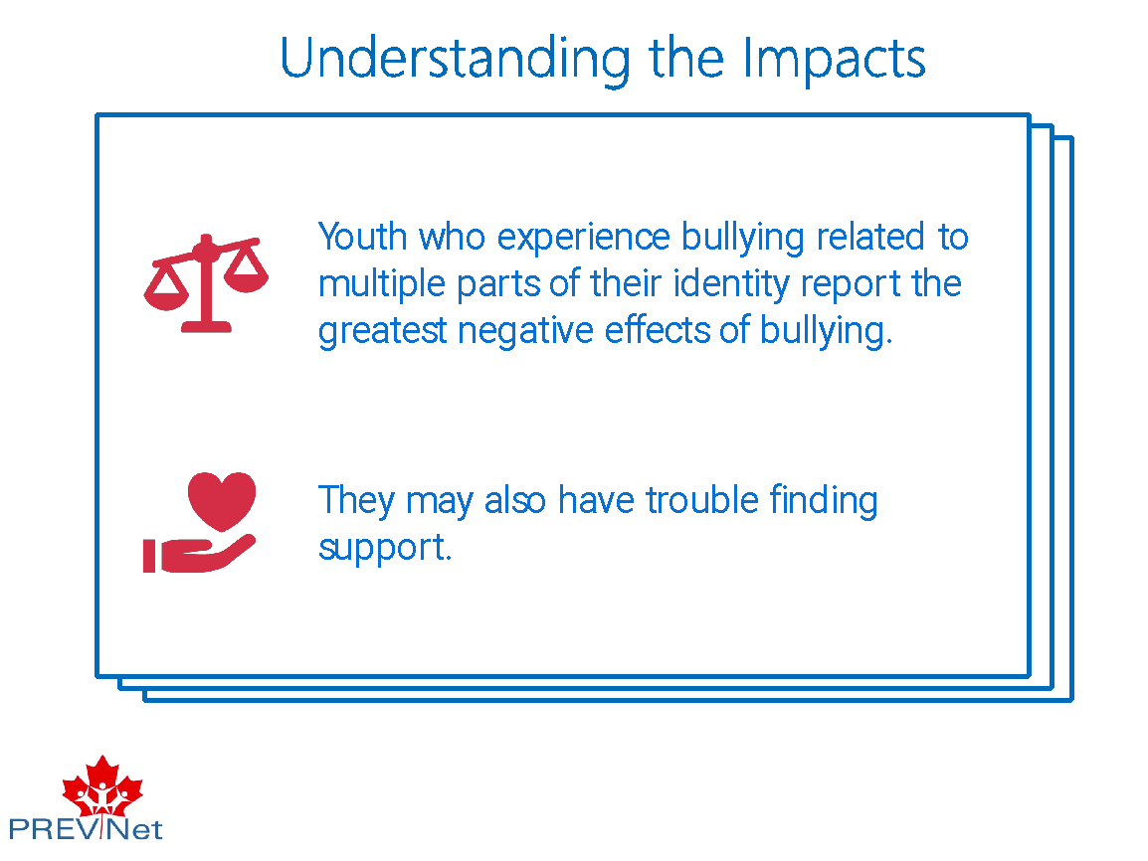 | Say:  - [CLICK] Adolescents who experience bullying related to multiple parts of their identity report the greatest negative effects of bullying.  - [CLICK] Teens who experience multiple forms of oppression, and therefore hold less social power, may also have trouble finding support as available spaces and resources may only focus on one form of oppression. For example, Ryan may find support from her school’s GSA regarding homophobic bullying, but the GSA group may not understand her experiences of racist bullying.  - If we don’t take the time to understand intersectionality, we can’t fully understand someone’s lived experience, and we unintentionally divide communities that should be working together. We need to understand how people’s experiences of oppression often overlap to cause people even more hardship. If we can understand that, we can create spaces in schools that meet students’ unique needs.
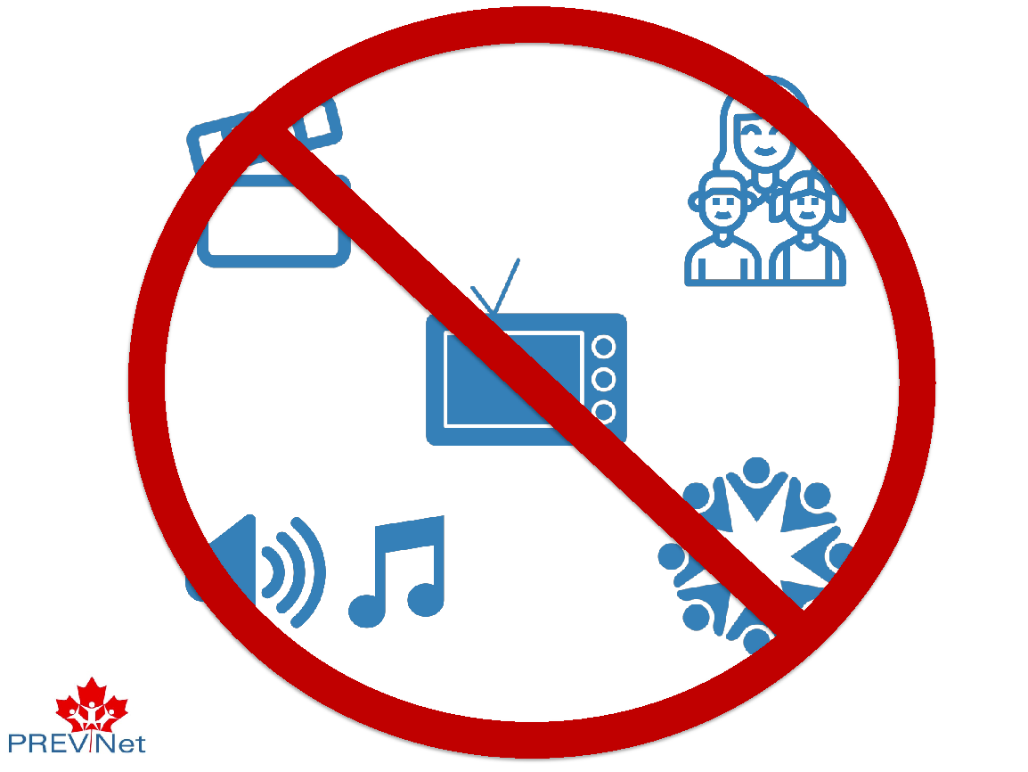 | Say:  - Remember, these beliefs about who should be treated well and who should be treated poorly are learned (either consciously or unconsciously) over our lifetimes. They are messages we hear from [CLICK] movies and songs, from [CLICK] families and friends, and [CLICK] in our own communities.  - At the societal level, there are many messages that tell us about who holds more power as compared to others.  - But, even though those messages are very present in society, [CLICK] we don’t have to accept them. Instead, we need to know better and do better in order to make a change. If we don’t realize that poor and unfair treatment of certain groups of people exists, we will just continue to follow the status quo and cause harm.
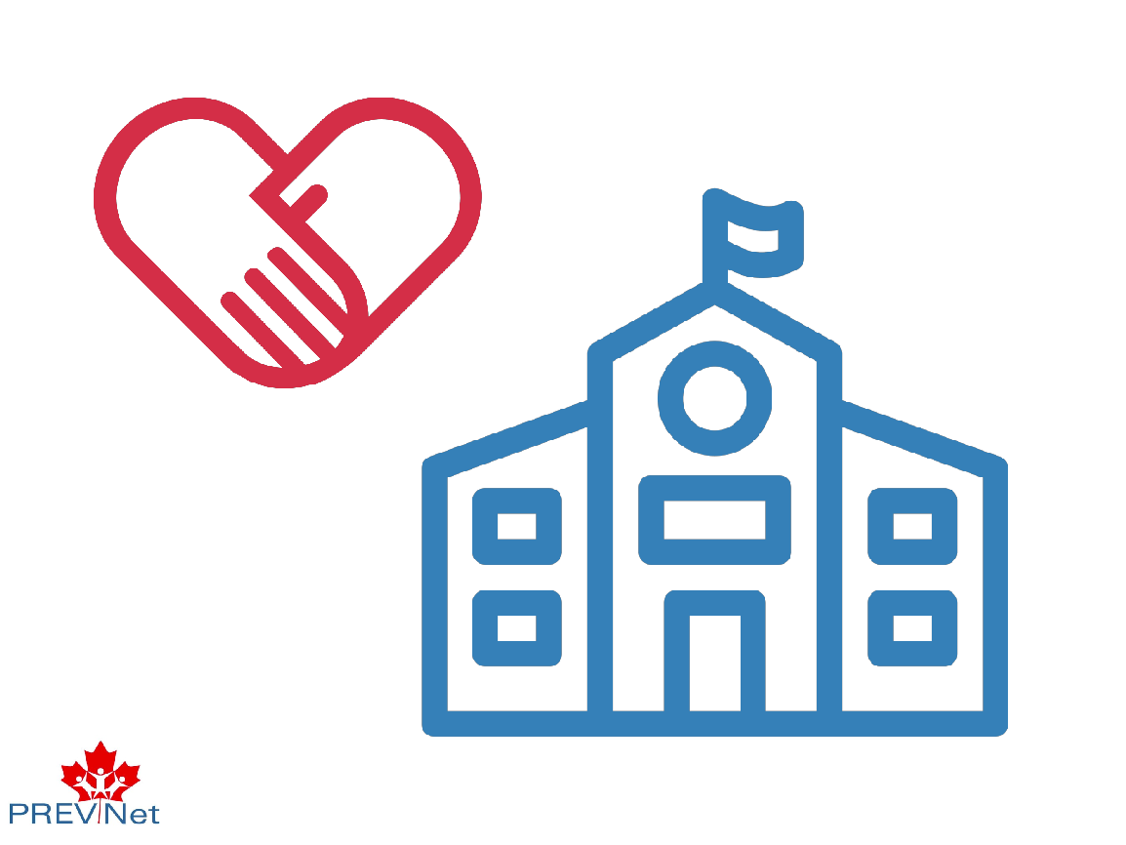 | Say:  - There are many things we can do right here in our classrooms and schools to make sure that everyone in our environment is respected, and be part of positive social change. [CLICK] In other presentations, we’ll talk about strategies we can use to create more inclusive environments and to make sure everyone can hold power.
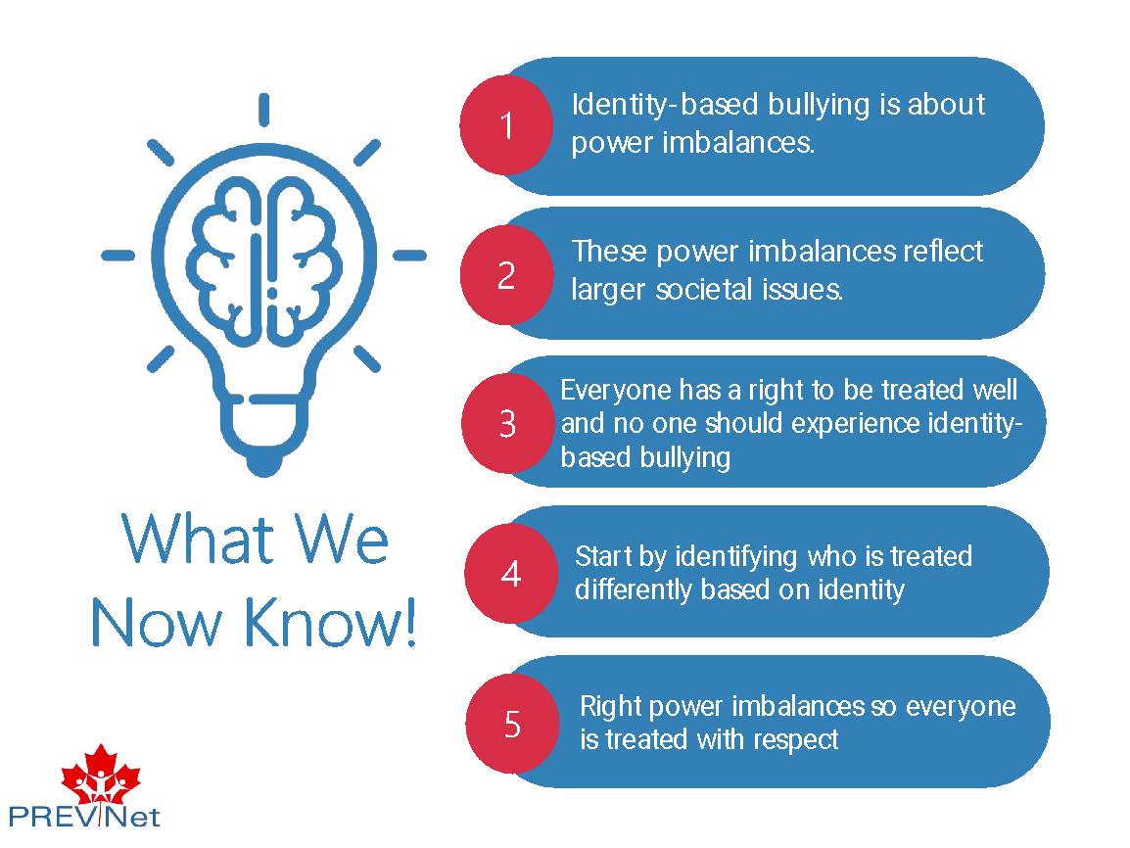 | Say:  - To summarize, [CLICK] identity-based bullying is about power imbalances. [CLICK] These power imbalances reflect larger societal issues about who has power and is privileged, and who has less power and is oppressed. Identity-based bullying targets specific groups of individuals and oppresses them further.  - Although people experience identity-based bullying for things that seem to be about “the individual person” (gender, sexual orientation), the reason these things give some people power over others is rooted in societal beliefs.  - [CLICK] Everyone has the right to be treated well, and no one should experience identity-based bullying.  - To make sure that everyone is respected in our schools, our classrooms, and in relationships between peers, [CLICK] we must first identify who is treated differently based on their identity. Becoming aware of people’s different identities and how this affects our attitudes and beliefs is a first step in preventing identity-based bullying in the classroom.  - Once we understand that, we can [CLICK] move towards learning how to use power positively to right the power imbalances so that everyone is treated with respect (something we’ll talk about in a future lesson).
